Name : Rajvardhan Reddy
Reg No : 180905093
Sec : B
Roll No : 19

CD LAB - 7 : RD PARSER FOR DECLARATION STATEMENTS

LAB EXERCISES :

P1) For given subset of grammar 7.1, design RD parser with appropriate error messages with expected character and row and column number.

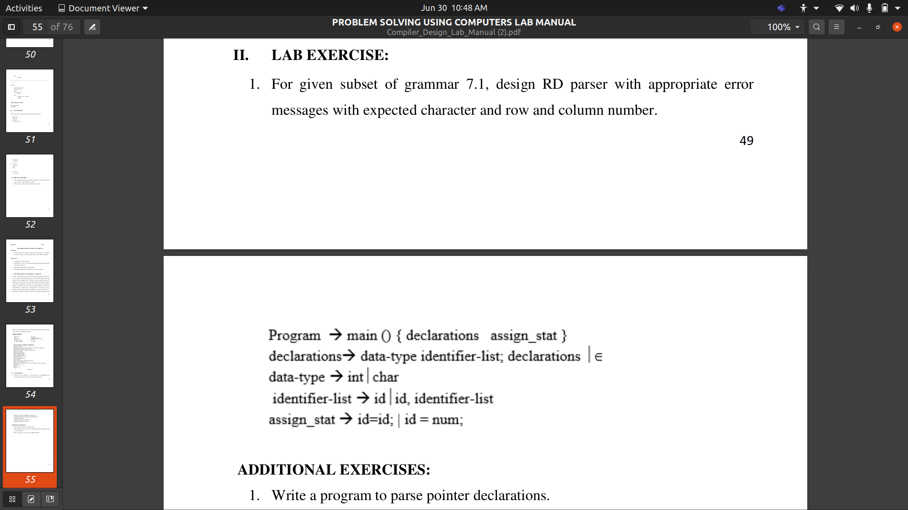

Program :
#include <stdio.h>
#include <stdlib.h>
#include <string.h>
#include <ctype.h>
struct token
{
char lexeme[64];
int row,col;
char type[20];
};
static int row=1,col=1;
char buf[2048];

const char specialsymbols[]={'?',';',':',','};
const char *keywords[] = {"const", "char", "int","return","for", "while", "do",
"switch", "if", "else","unsigned", "case", "break" };

const char *datypes[]={"int","char","void","float","bool"};

const char arithmeticsymbols[]={'*'};
int isdtype(char *w)
{
int i;
for(i=0;i<sizeof(datypes)/sizeof(char*);i++)
{
if(strcmp(w,datypes[i])==0)
{
return 1;
}}
return 0;
}
int isKeyword(const char *str)
{
for(int i=0;i<sizeof(keywords)/sizeof(char*);i++)
{
if(strcmp(str,keywords[i])==0)
{
return 1;
}
}
return 0;
}

int charBelongsTo(int c,const char *arr)
{
int len;
if(arr==specialsymbols)
{
len=sizeof(specialsymbols)/sizeof(char);
}
else if(arr==arithmeticsymbols)
{
len=sizeof(arithmeticsymbols)/sizeof(char);
}
for(int i=0;i<len;i++)
{
if(c==arr[i])
{
return 1;
}
}
return 0;
}

void fillToken(struct token *tkn,char c,int row,int col, char *type)
{
tkn->row=row;
tkn->col=col;
strcpy(tkn->type,type);
tkn->lexeme[0]=c;
tkn->lexeme[1]='\0';
}

void newLine()
{
++row;
col=1;
}

struct token getNextToken(FILE *f1)
{
int c;
struct token tkn=
{
.row=-1
};
int gotToken=0;
while(!gotToken && (c=fgetc(f1))!=EOF)
{
if(charBelongsTo(c,specialsymbols))
{
fillToken(&tkn,c,row,col,"specialsymbol");
gotToken=1;
++col;
}
else if(charBelongsTo(c,arithmeticsymbols))
{
fillToken(&tkn,c,row,col,"arithmetic operator");
gotToken=1;
++col;
}
else if(c=='(')
{
fillToken(&tkn,c,row,col,"left bracket");
gotToken=1;
++col;
}
else if(c==')')
{
fillToken(&tkn,c,row,col,"right bracket");
gotToken=1;
++col;
}
else if(c=='{')
{
fillToken(&tkn,c,row,col,"left curly");
gotToken=1;
++col;
}
else if(c=='}')
{
fillToken(&tkn,c,row,col,"right curly");
gotToken=1;
++col;
}
else if(c=='+')
{
int d=fgetc(f1);
if(d!='+')
{
fillToken(&tkn,c,row,col,"arithmetic operator");
gotToken=1;
++col;
fseek(f1,-1,SEEK_CUR);
}
else
{
fillToken(&tkn,c,row,col,"unary operator");
strcpy(tkn.lexeme,"++");
gotToken=1;
col+=2;
}
}
else if(c=='-')
{
int d=fgetc(f1);
if(d!='-')
{
fillToken(&tkn,c,row,col,"arithmetic operator");
gotToken=1;
++col;
fseek(f1,-1,SEEK_CUR);
}
else
{
fillToken(&tkn,c,row,col,"unary operator");
strcpy(tkn.lexeme,"--");
gotToken=1;
col+=2;
}
}
else if(c=='=')
{
int d=fgetc(f1);
if(d!='=')
{
fillToken(&tkn,c,row,col,"assignment operator");
gotToken=1;
++col;
fseek(f1,-1,SEEK_CUR);
}
else
{
fillToken(&tkn,c,row,col,"relational operator");
strcpy(tkn.lexeme,"==");
gotToken=1;
col+=2;
}
}
else if(isdigit(c))
{
tkn.row=row;
tkn.col=col++;
tkn.lexeme[0]=c;
int k=1;
while((c=fgetc(f1))!=EOF && isdigit(c))
{
tkn.lexeme[k++]=c;
col++;
}
tkn.lexeme[k]='\0';
strcpy(tkn.type,"number");
gotToken=1;
fseek(f1,-1,SEEK_CUR);
}
else if(c == '#')
{
while((c = fgetc(f1)) != EOF && c != '\n');
newLine();
}
else if(c=='\n')
{
newLine();
c = fgetc(f1);
if(c == '#')
{
while((c = fgetc(f1)) != EOF && c != '\n');
newLine();
}
else if(c != EOF)
{
fseek(f1, -1, SEEK_CUR);
}
}
else if(isspace(c))
{
++col;
}
else if(isalpha(c)||c=='_')
{
tkn.row=row;
tkn.col=col++;
tkn.lexeme[0]=c;
int k=1;
while((c=fgetc(f1))!= EOF && isalnum(c))
{
tkn.lexeme[k++]=c;
++col;
}
tkn.lexeme[k]='\0';
if(isKeyword(tkn.lexeme))
{
strcpy(tkn.type,"keyword");
}
else
{
strcpy(tkn.type,"identifier");
}
gotToken=1;
fseek(f1,-1,SEEK_CUR);
}
else if(c=='/')
{
int d=fgetc(f1);
++col;
if(d=='/')
{
while((c=fgetc(f1))!= EOF && c!='\n')
{
++col;
}
if(c=='\n')
{
newLine();
}
}
else if(d=='*')
{
do
{
if(d=='\n')
{
newLine();
}
while((c==fgetc(f1))!= EOF && c!='*')
{
++col;
if(c=='\n')
{
newLine();
}
}
++col;
}while((d==fgetc(f1))!= EOF && d!='/' && (++col));
++col;
}
else
{
fillToken(&tkn,c,row,--col,"arithmetic operator");
gotToken=1;
fseek(f1,-1,SEEK_CUR);
}
}
else if(c == '"')
{
tkn.row = row;
tkn.col = col;
strcpy(tkn.type, "string literal");
int k = 1;
tkn.lexeme[0] = '"';
while((c = fgetc(f1)) != EOF && c != '"')
{
tkn.lexeme[k++] = c;
++col;
}
tkn.lexeme[k] = '"';
gotToken = 1;
}
else if(c == '<' || c == '>' || c == '!')
{
fillToken(&tkn, c, row, col, "relational operator");
++col;
int d = fgetc(f1);
if(d == '=')
{
++col;
strcat(tkn.lexeme, "=");
}
else
{
if(c == '!')
{
strcpy(tkn.type, "logical operator");
}
fseek(f1, -1, SEEK_CUR);
}
gotToken = 1;
}
else if(c == '&' || c == '|')
{
int d = fgetc(f1);
if(c == d)
{
tkn.lexeme[0] = tkn.lexeme[1] = c;
tkn.lexeme[2] = '\0';
tkn.row = row;
tkn.col = col;
++col;
gotToken = 1;
strcpy(tkn.type, "logical operator");
}
else
{
fseek(f1, -1, SEEK_CUR);
}
++col;
}
else
{
++col;
}
}
return tkn;
}

void program();
void declarations();
void data_type();
void identifier_list();
void assign_stat();

struct token curr;
FILE *f1;
void invalid(){
printf("error");
exit(0);
}
void program()
{

if(strcmp(curr.lexeme,"main")==0)
{
curr=getNextToken(f1);
if(strcmp(curr.lexeme,"(")==0)
{
curr=getNextToken(f1);
if(strcmp(curr.lexeme,")")==0)
{
curr=getNextToken(f1);
if(strcmp(curr.lexeme,"{")==0)
{
curr=getNextToken(f1);
declarations();
assign_stat();
if(strcmp(curr.lexeme,"}")==0)
{
return;
}
else
{
printf("\nMissing } at row:%d and col:%d.\n\n",curr.row,curr.col);
exit(0);
}
}
else
{
printf("\nMissing { at row:%d and col:%d.\n\n",curr.row,curr.col);
exit(0);
}
}
else
{
printf("\nMissing ) at row:%d and col:%d.\n\n",curr.row,curr.col);
exit(0);
}
}
else
{
printf("\nMissing ( at row:%d and col:%d.\n\n",curr.row,curr.col);
exit(0);
}
}
else
{
printf("\nMissing main function\n\n");
exit(0);
}
}

void declarations()
{

if(isdtype(curr.lexeme)==0)
{
return;
}
data_type();
identifier_list();
if(strcmp(curr.lexeme,";")==0)
{
curr=getNextToken(f1);
declarations();
}
else {printf("\nMissing ; at row:%d and col:%d.\n\n",curr.row,curr.col); exit(0);}
}

void data_type()
{
if(strcmp(curr.lexeme,"int")==0)
{
curr=getNextToken(f1);
return;
}
else if(strcmp(curr.lexeme,"char")==0)
{
curr=getNextToken(f1);
return;
}
else
{
printf("\nMissing data type at row:%d and col:%d.\n\n",curr.row,curr.col);
exit(0);
}
}

void identifier_list()
{
if(strcmp(curr.type,"identifier")==0)
{
curr=getNextToken(f1);
if(strcmp(curr.lexeme,",")==0)
{
curr=getNextToken(f1);
identifier_list();
}
else return;
}

else
{
printf("\nMissing identifier at row:%d and col:%d.\n\n",curr.row,curr.col);
exit(0);
}
}

void assign_stat()
{
if(strcmp(curr.type,"identifier")==0)
{
curr=getNextToken(f1);
if(strcmp(curr.lexeme,"=")==0)
{
curr=getNextToken(f1);
if(strcmp(curr.type,"identifier")==0)
{
curr=getNextToken(f1);
if(strcmp(curr.lexeme,";")==0)
{
curr=getNextToken(f1);
return;
}
}

else if(strcmp(curr.type,"number")==0)
{
curr=getNextToken(f1);
if(strcmp(curr.lexeme,";")==0)
{
curr=getNextToken(f1);
return;
}
else
{
printf("\nMissing ; at row:%d and col:%d.\n\n",curr.row,curr.col);
exit(0);
}

}
else
{
printf("\nMissing identifier at row:%d and col:%d.\n\n",curr.row,curr.col);
exit(0);
}
}
else
{
printf("\nMissing = at row:%d and col:%d.\n\n",curr.row,curr.col);
exit(0);
}
}
else
{
printf("\nMissing identifier at row:%d and col:%d.\n\n",curr.row,curr.col);
exit(0);
}
}

int main()
{
FILE *fa, *fb;
int ca, cb;
fa = fopen("input.c", "r");
if (fa == NULL){
printf("Cannot open file \n");
return 0;
}
fb = fopen("fileout.c", "w");
ca = getc(fa);
while (ca != EOF){
if(ca==' ')
{
putc(ca,fb);
while(ca==' ')
ca = getc(fa);
}
if (ca=='/')
{
cb = getc(fa);
if (cb == '/')
{
while(ca != '\n')
ca = getc(fa);
}
else if (cb == '*')
{
do
{
while(ca != '*')
ca = getc(fa);
ca = getc(fa);
} while (ca != '/');
}
else{
putc(ca,fb);
putc(cb,fb);
}
}
else putc(ca,fb);
ca = getc(fa);
}
fclose(fa);
fclose(fb);
fa = fopen("fileout.c", "r");
if(fa == NULL){
printf("Cannot open file");
return 0;
}
fb = fopen("temp.c", "w");
ca = getc(fa);
while(ca != EOF){
if(ca == '#'){
while(ca != '\n'){
ca = getc(fa);
}
}
ca = getc(fa);
if(ca != EOF && ca != '#'){
putc(ca, fb);
}
}
fclose(fa);
fclose(fb);
fa = fopen("temp.c", "r");
fb = fopen("fileout.c", "w");
ca = getc(fa);
while(ca != EOF){
putc(ca, fb);
ca = getc(fa);
}
fclose(fa);
fclose(fb);
remove("temp.c");
f1=fopen("fileout.c","r");
if(f1==NULL)
{
printf("Error! File cannot be opened!\n");
return 0;
}
struct token tkn;
curr=getNextToken(f1);
program();
printf("\nCompiled\n\n");
fclose(f1);
}

Output :
